

Average Rangers | SCSD2613/08 | December 10, 2015

SYSTEM ANALYSIS & DESIGN

FINAL REPORT



**Faculty of Computing**

**SCSD2613**

**System Analysis & Design**

***2015/2016***

***SESSION 08***

***DR. NORSHAM BINTI IDRIS 7321***

#### **Average Rangers**

MOHAMMAD ZULKIFLI BIN ZAINUL

A14CS0173

QURATUL AIN NABIHAH BINTI MOHD HIZAM

A14CS0126

YAP YOONG SENG

A14CS0150

Contents

INTRODUCTION 3

Background study 3

Current problem 3

Proposed system solution 4

Objective 5

Scope 5

Benefits 5

PROJECT PLAN 6

Economic feasibility 6

Gantt chart 7

Pert diagram 7

Software to be used in the system 9

SYSTEMS ANALYSIS 10

Context level diagram 10

Level 0 diagram & Child diagram 11

SYSTEMS DESIGN 16

Physical DFD design 16

Database model design 16

Structure chart 17

System interface design 18

# INTRODUCTION

## Background study

Our team had chosen education as our theme for our group project’s system. The three of us agreed to choose SMK Taman Nusa Damai as our study case. SMK Taman Nusa Damai is located at Pasir Gudang, Johor, that distanced 41.1km away from Universiti Teknologi Malaysia (UTM), Skudai, Johor. Upon our research, we had an interview with our client, who is the school’s official senior assistant named Pn. Wardah binti Ismail. With the help of the schools’ staffs we managed to gain and gather the information that we wanted. Pn. Wardah as senior assistant, support in administration of school is her job. From the statement of Pn. Wardah, she has been worked in the school about 35 years. Therefore, she is absolutely one of the experienced staff that able to explain the current problem of the school regarding to the subject registration system.

## Current problem

After our team has collected the data from the school, we noticed that they do not own their system or database. The registration is manually handled by the staffs. For instance, the students have to fill the information in the subject registration form that distributed by teachers during opening school, and the filled form is submitted to teachers then passed to secretary. After that, the secretary stores the hardcopy forms in files. Consequently, since the system has not been computerized, it increases the working time of staffs as they are still handling as paper-work system. Therefore, this will cause worse problems to them if they still do not own their system in future.

1. There is no storage for them to record all the data in their school especially more specific data that they need to record as well as student record, staff record, teacher record, class record and other necessary records.
2. There will cause confusion towards their staff. There is certain probability that the staff will randomly doing mistakes such as putting the subject file at student file. Thus, this makes the manual registration system is more complicated.
3. There is also causes minor problem that the staffs want to search the record and it take so much time to find a file that they are looking for.
4. Another severe problem is that the school does not have backup of the record. Even for the worst, the record is destroyed due to inevitable disaster.

## Proposed system solution

Number of students for each subject

Student ID

0

Subject Registration

Student

Subject

Students’ schedule

Subjects offered

Teacher ID

Teachers’ schedule

Teacher

*Figure 1*

The Figure 1 is the context diagram of Student Subject Registration System.

There are 3 entities involved in the system, Student, Subject and Teacher while the system is Subject Registration. Firstly, the student ID data will flow from Student entity into Subject Registration. If the student ID is granted access, the student may start the subject registration process. Meanwhile, the student can click search on each class to see if the class fit their subjects wanted. For example, 5 Perdana class available for the subjects Additional Mathematics, Biology, Chemistry, Physics, English Language, Malay Language, Mathematics, Moral Education, Islamic Education, History and other classes also available different subjects. The subject entity delivers the subjects offered data to the Subject Registration. From the system to Subject entity, the data of number of students taking the subject is flowed. For example, the student is registering for Biology subject, the system will increment the number of students taking the Biology subject into the Subject entities. After the student is done on subject registration, the schedule will be given to the student. While for the Teacher entity, it also will flow the teacher ID data into Subject Registration. After the teacher ID is granted access, the teacher may register the class and subject that they wanted to teach. As a return, the teachers’ schedule will be produced and send into Teacher entity.

## Objective

The student subject registration system is a system that computerizes the process of the subject registration for the students. Other than that, it is a convenience for the school administrative as the proposed student subject registration system is a lot more organized and reliable. The client required the system because they do not have a computer system instead they are still using a traditional system.

## Scope

The constraint identified for the system development are including:

1. There is no budget to design the computer system because the school does not receive any budget from the government itself.
2. There no enough staff to handle the system or design the database for the school.
3. There are so many files that has not been computerized. This will complicate the problem or even data loss when they want integrate between old records and new records.

## Benefits

The benefits gained from the Student Subject Registration System are:

1. All the data which including students’ information, students’ subject, students’ class, teacher are easier to record and maintain.
2. It is easier for the staff to search a specific record that they require.
3. The system can retrieve the data if unavoidable disaster is happened.
4. It can shorten the time taken to process all the data into records.
5. The system is more organized and reliable for the client.
6. It can save up much space as all the record kept in database instead of physical paper files.

# PROJECT PLAN

## Economic feasibility

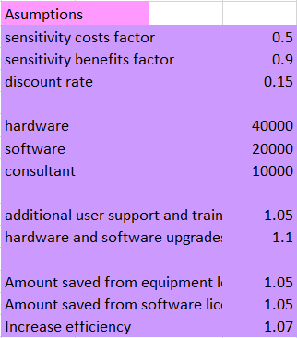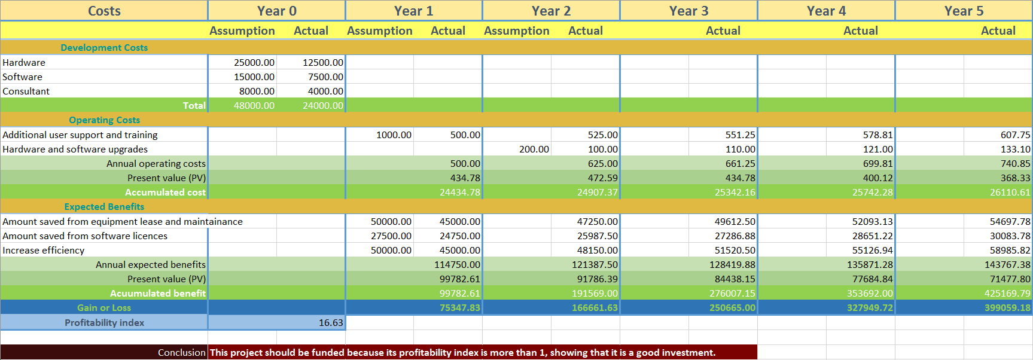

## Gantt chart

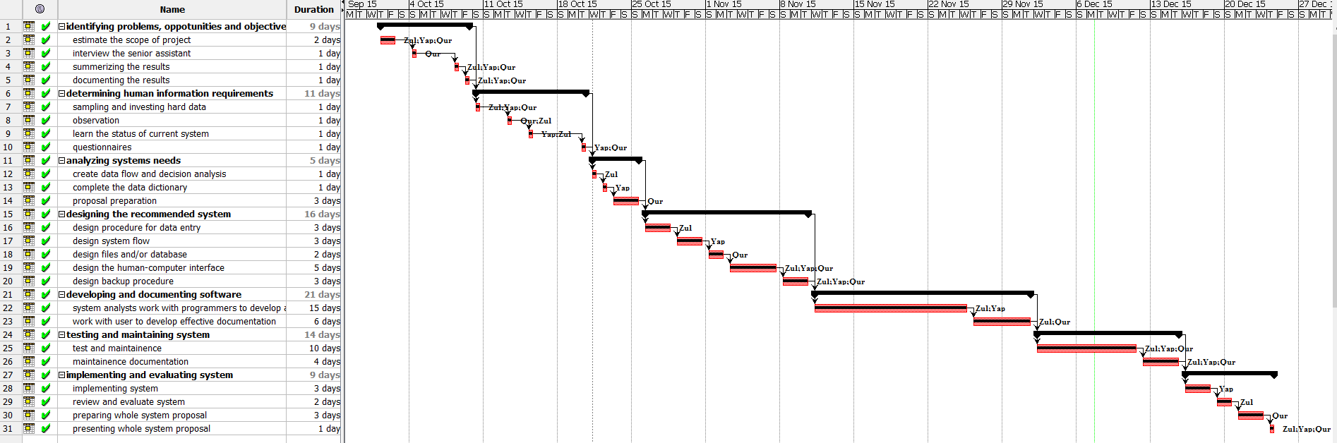

## Pert diagram

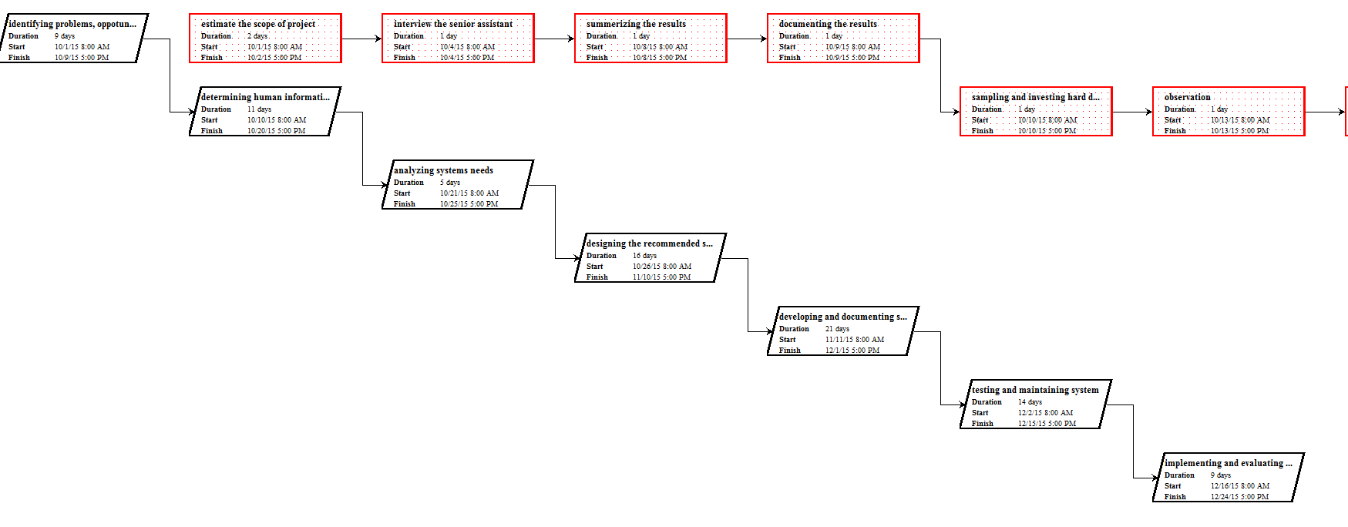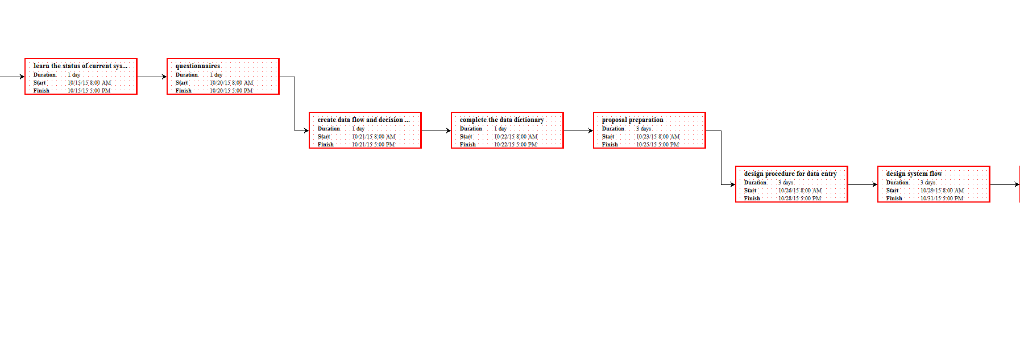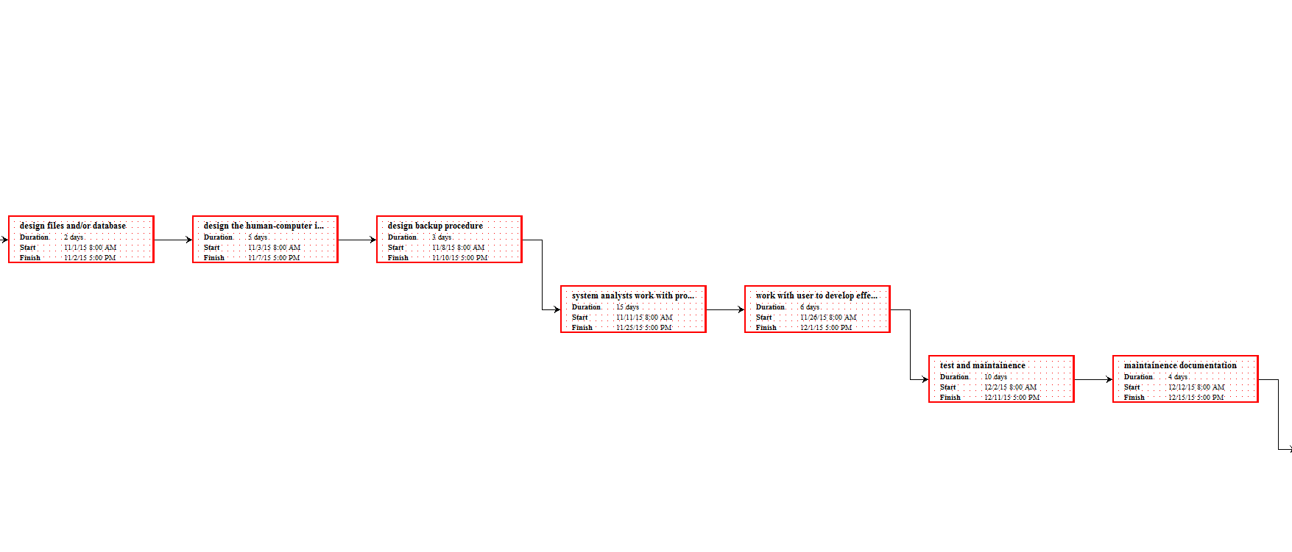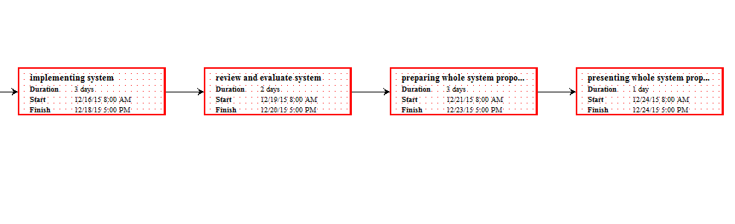

## Software to be used in the system

The schedule that containing proper phases, specified tasks and activities for all the members in the group is made by using software ProjectLibre. Besides that, the Gantt chart and Pert diagrams are also made by using the same software. The Wampserver software is used for creating the connection online for database. While for the database management tool, our team used the Navicat. The data flow diagram (DFD) is made by Lucidchart website (www.lucidchart.com).

# SYSTEMS ANALYSIS

In the information gathering methods, our team has used the questionnaires and interview. The questionnaires along with its feedback from respondents are attached into appendix.

For the questionnaires,

## Context level diagram

Number of students for each subject

Student ID

0

Subject Registration

Student

Subject

Students’ schedule

Subjects offered

Teacher ID

Teachers’ schedule

Teacher

*Figure 2*

## Level 0 diagram & Child diagram

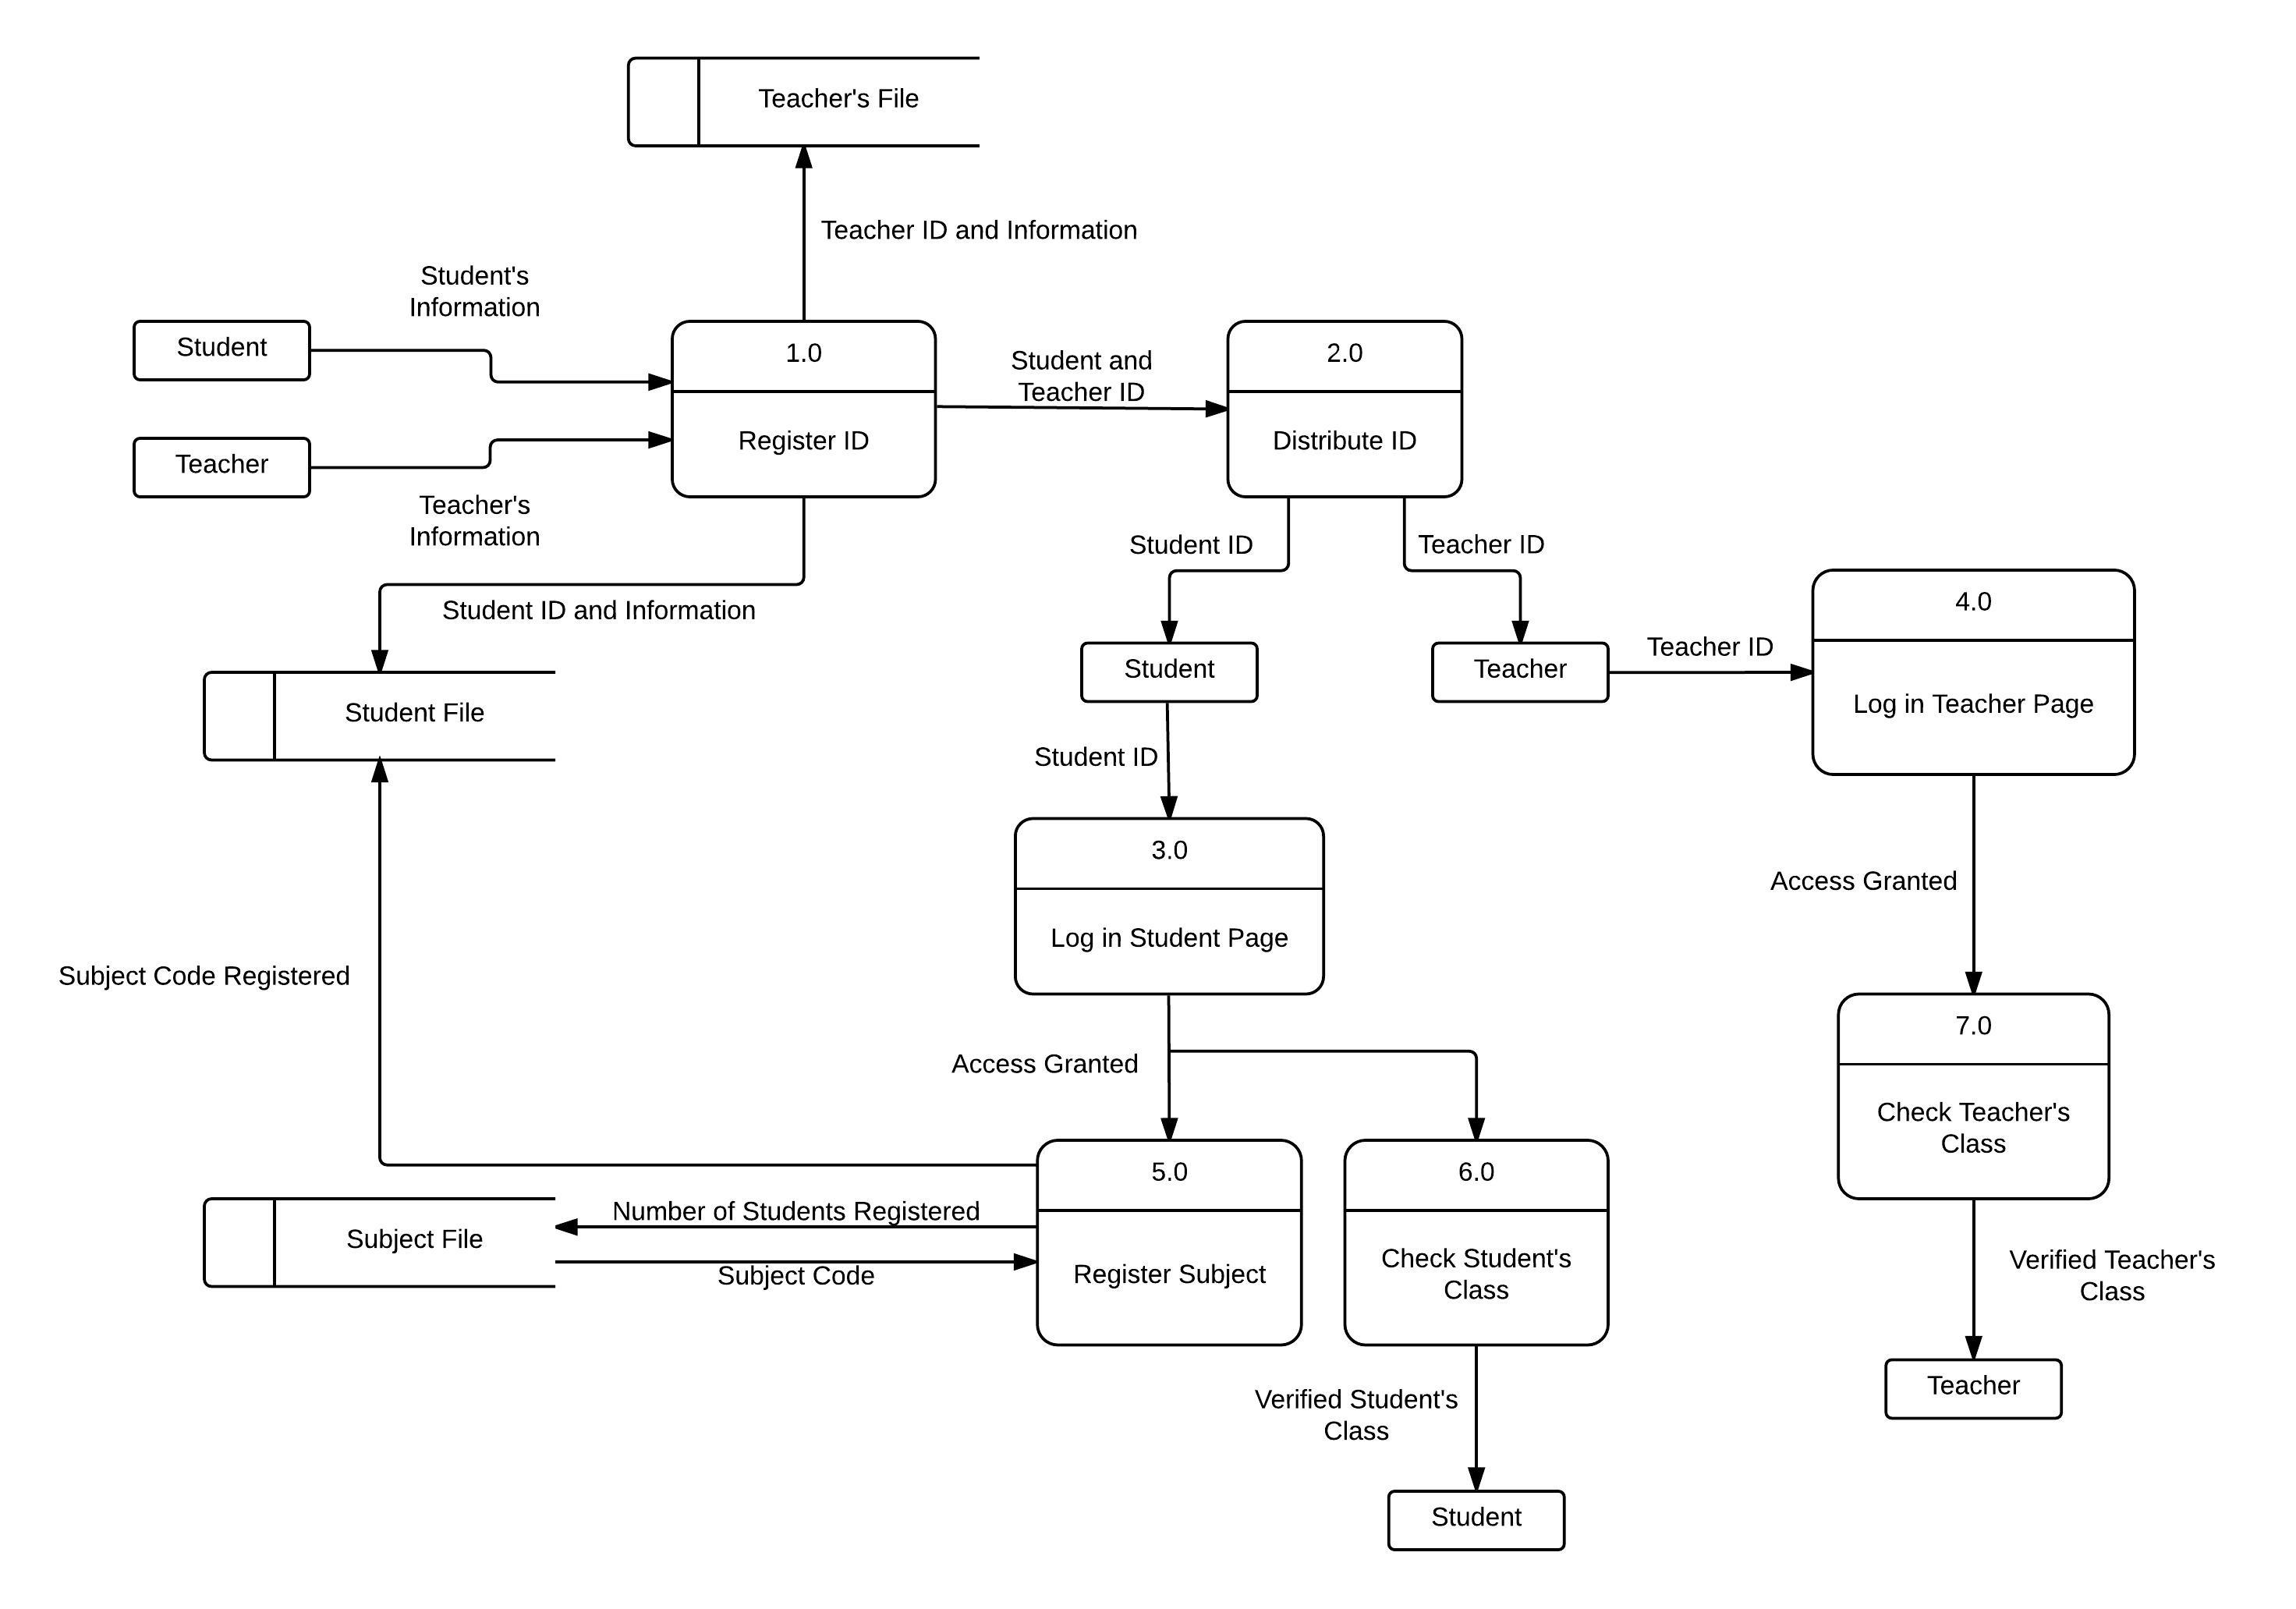

*Figure 3*

The Figure 3 is the level 0 diagram of Student Subject Registration System. In this system, there are 7 processes involved in the system. The processes are including register ID, distribute ID, login student page, login teacher page, register subject, check student’s class and check teacher’s class.

* 1. REGISTER ID

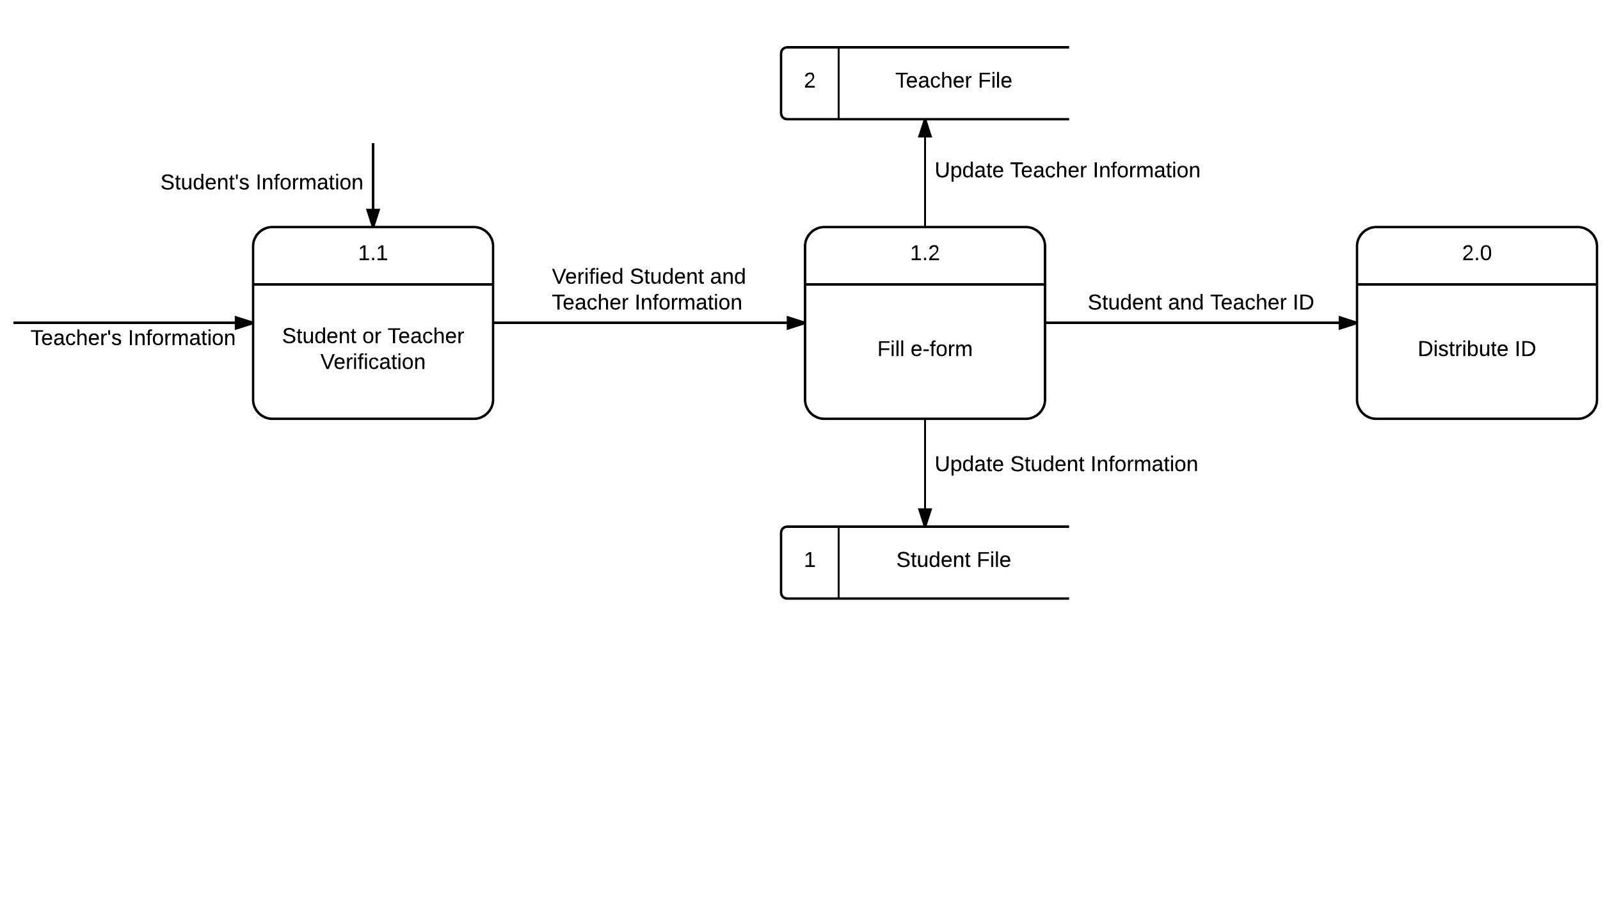

*Figure 4*

The first process of Student Subject Registration System is register ID. The Figure 4 is child diagram of Register ID process. Firstly, the student and teacher fill up their information on the e-form of registration website. These information is then will be checked by staff. Once the staff checked that information filled is identical to the information collected from their registration form during opening school, the staff will generate a new unique ID for each student and teacher. After that, the student ID along with student information will be stored in data store named Student File. While for the teacher, another data store named Teacher File contains the teacher ID and teacher information from the register ID process.

* 1. DISTRIBUTE ID

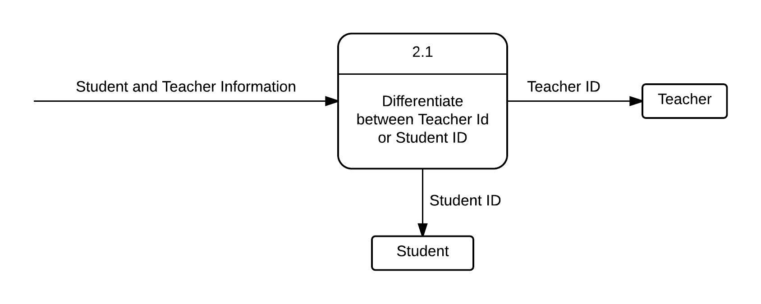

*Figure 5*

The next process is distribute ID. The Figure 5 is child diagram of Distribute ID process. The staff differentiate between student ID and teacher ID then distribute them to student and teacher respectively. The staff distribute the ID through e-mail.

1.3 LOGIN STUDENT PAGE

Once the students got their ID, they can proceed to the consequence process which is login student page. The student is then gained the verification access. In this phase, the students can continue to 2 processes, either register the subjects or check schedule after the subject registration.

1.4 LOGIN TEACHER PAGE

After the teachers got their ID, they can proceed to the next process which is login teacher page. The teacher is then gained the verification access and continue to next process, check teacher schedule.

1.5 REGISTER SUBJECT

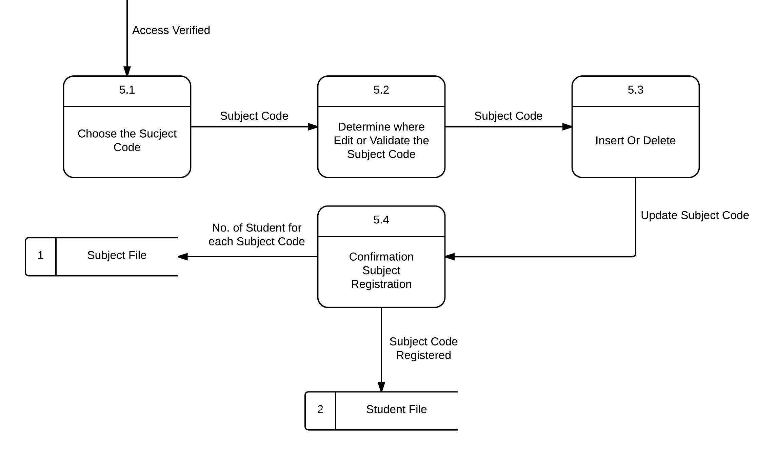

*Figure 6*

The Figure 6 is child diagram of Register Subject process. In the subject registration, the students are allowed to select the subjects after the access is verified. The Subject File imports the subject code that complementing the related subject, the students then select the subjects. The subject code that students are taking will be sent to next phase. The list of displaying subject registered along with subject code is shown to students. In case if the students are selected wrong subject, they can perform insertion or deletion of subject, then update the subject code again. The students are then proceeding to confirmation of subject registered by them. Once they are confirmed, the subject code registered will be inserted into the Student File, for storing the subjects that taken by a student. In the same time, it will also increment the number of student that taking a particular subject. The number of students that taking a particular subject will be updated into Subject File.

1.6 CHECK STUDENT CLASS

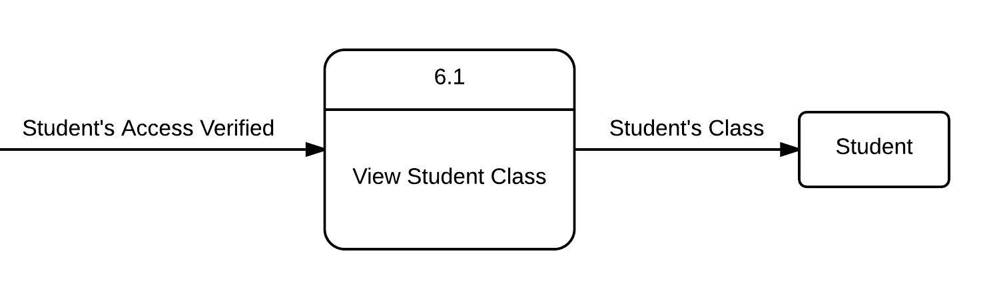

*Figure 7*

The Figure 7 is child diagram of Check Student Class process. The students can check their schedule to identify if their schedule is crashed or error in arranging the time. For example, the Chemistry and Biology subject are arranged at the same time, 10am. If there is no error on schedule, they may proceed to their schedule.

1.7 CHECK TEACHER CLASS

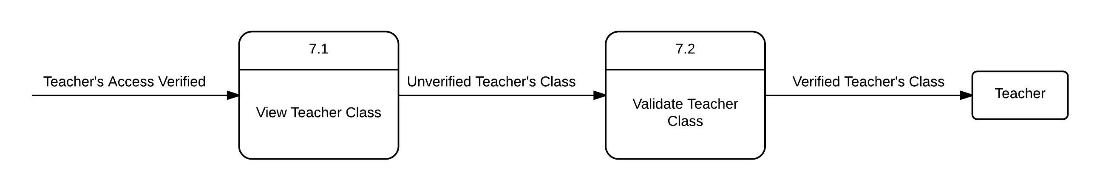

*Figure 8*

The Figure 8 is child diagram of Check Teacher Class process. The teachers can determine their schedule if they are teaching the wrong subject. In instance, the teacher that supposed to teach Malay Language but mistaken arranged to teach English Language. If there is no error on schedule, they may proceed to their schedule.

# SYSTEMS DESIGN

## Physical DFD design

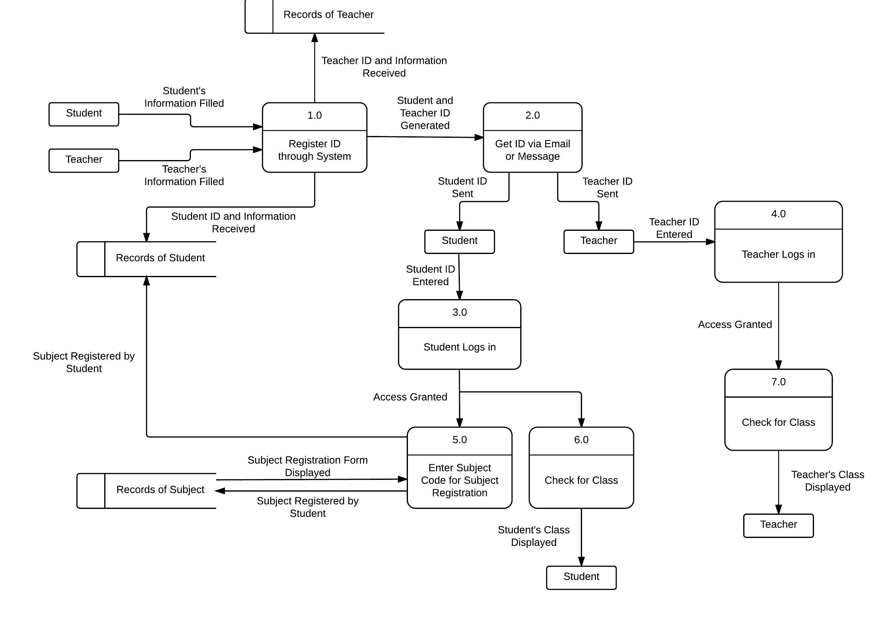

## Database model design

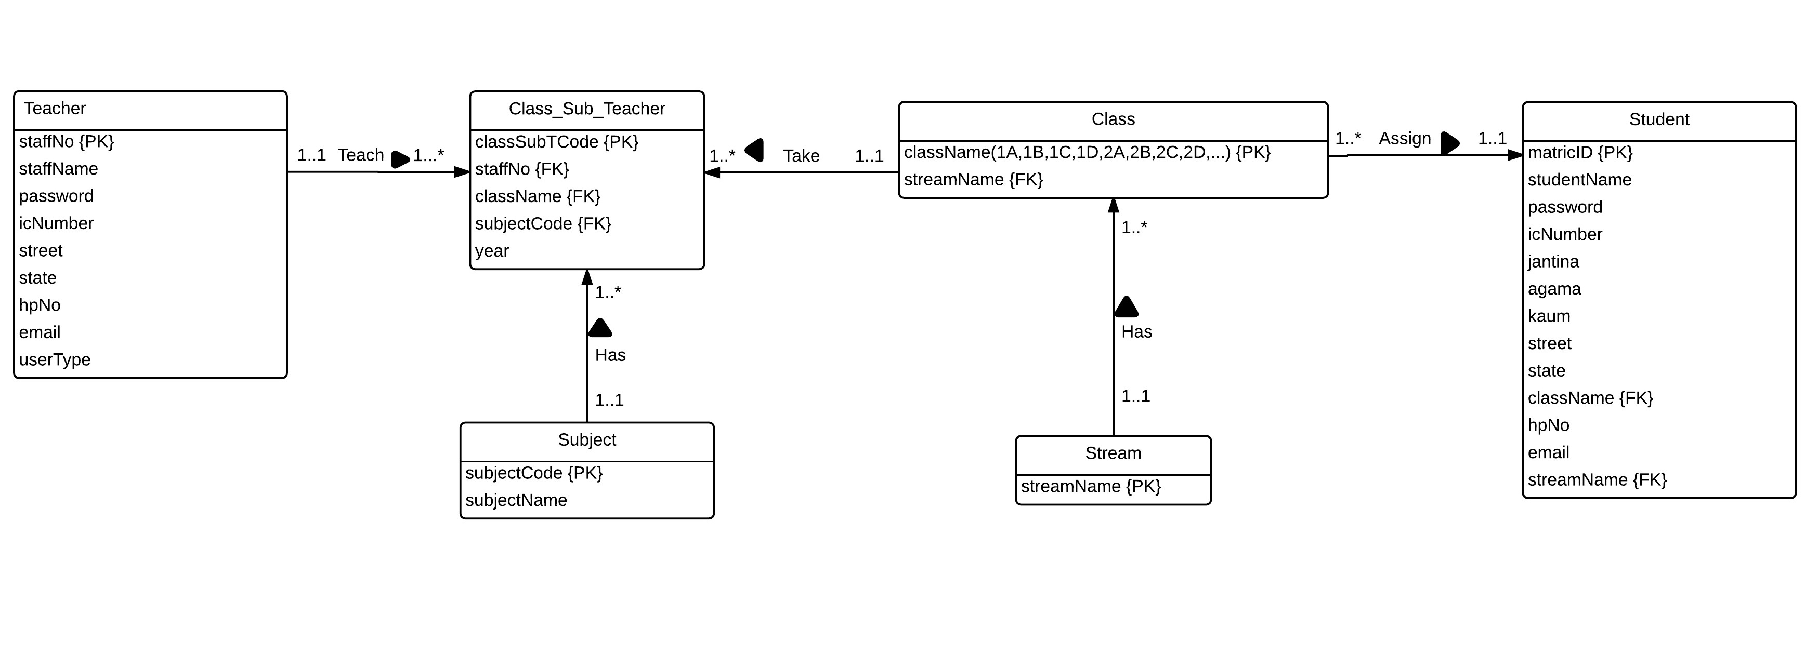

## Structure chart

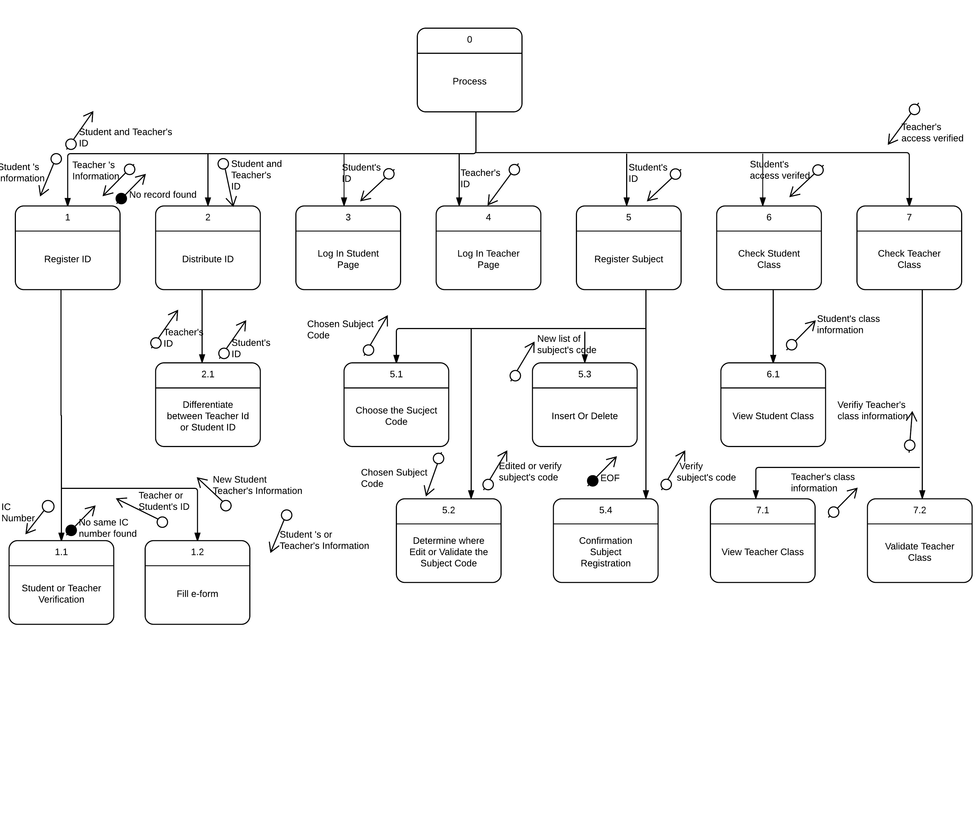

## System interface design

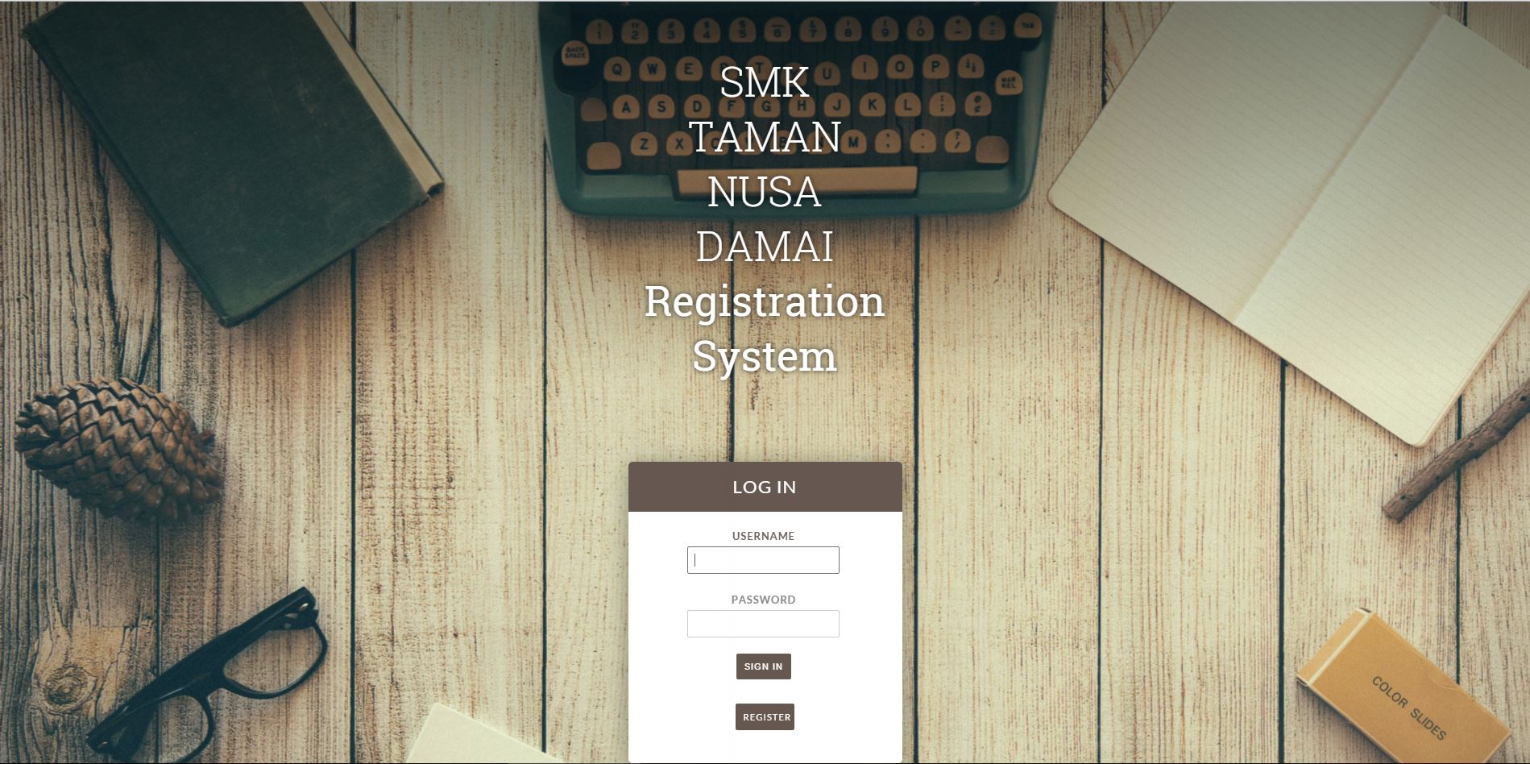

*Figure 9 shows the main login page of SMK Taman Nusa Damai Registration System.*

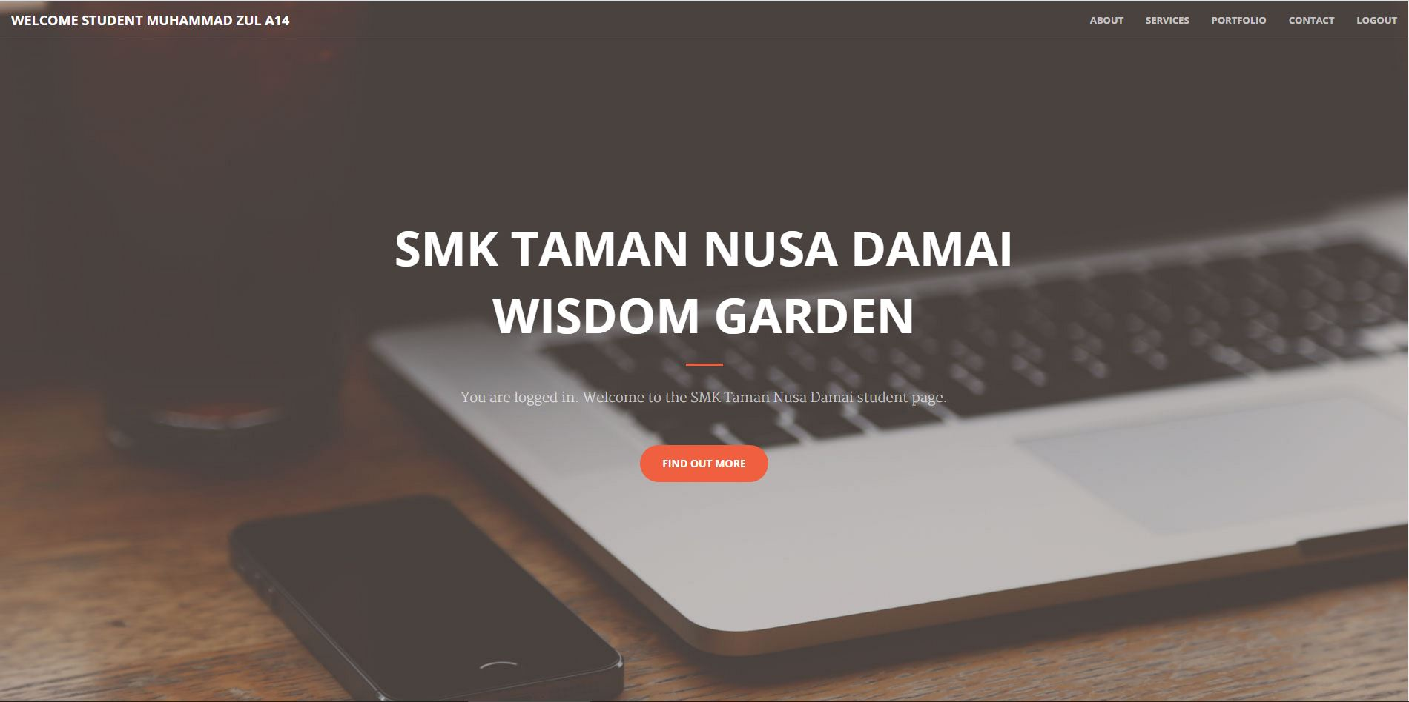

*Figure 10 shows the interface of student page after the student ID is granted access.*

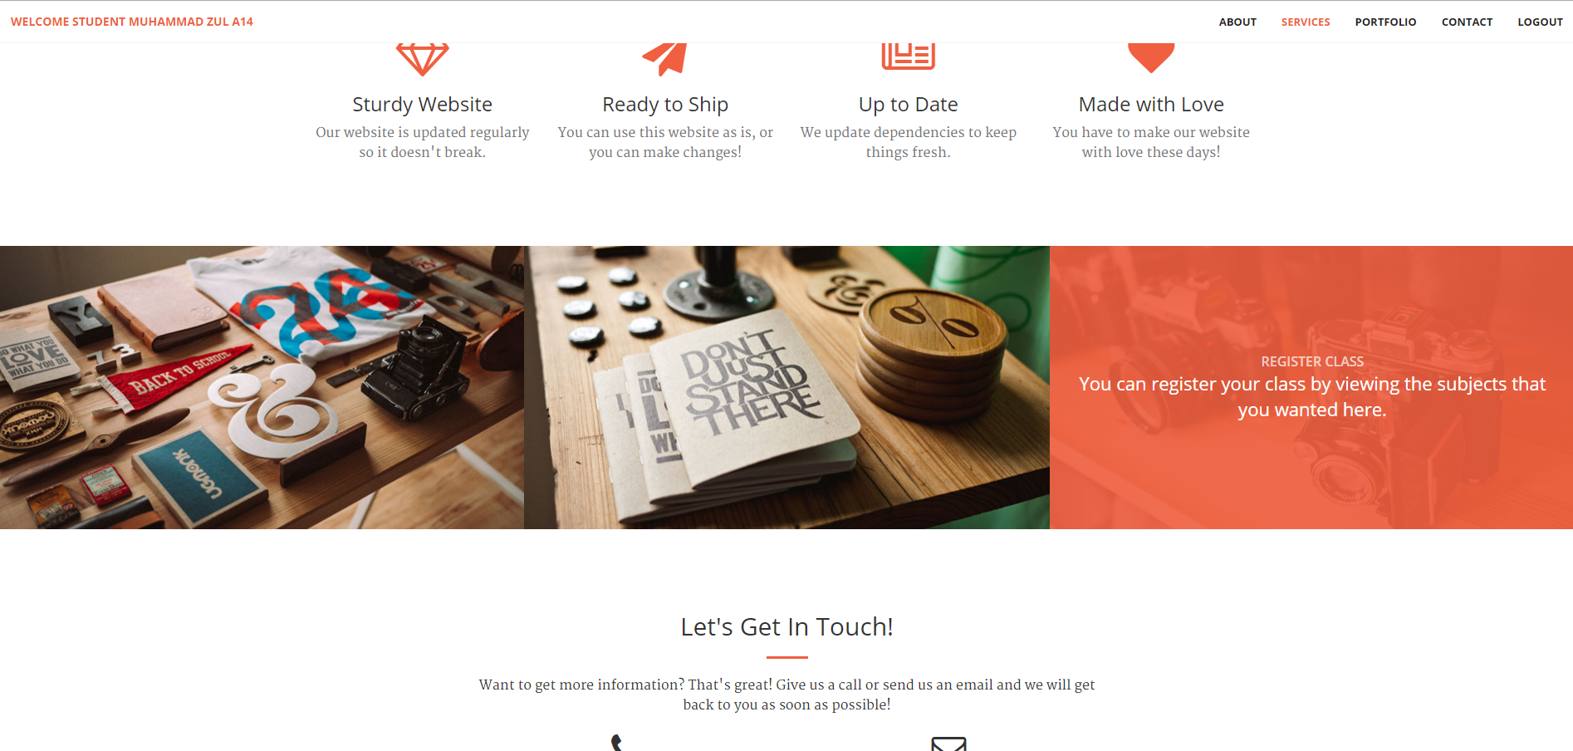

*Figure 11 shows the below page of Figure 10 by scrolling down the page, by approaching the pictures, the users can see the functionality and task.*

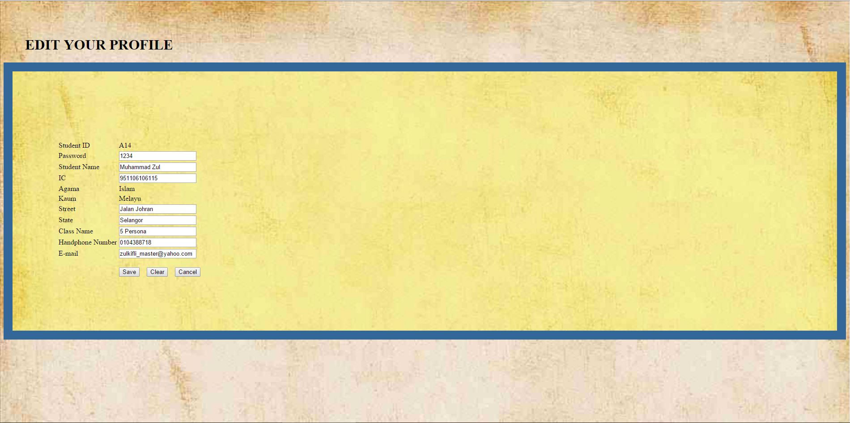

*Figure 12 shows the interface of editing profile of a student.*

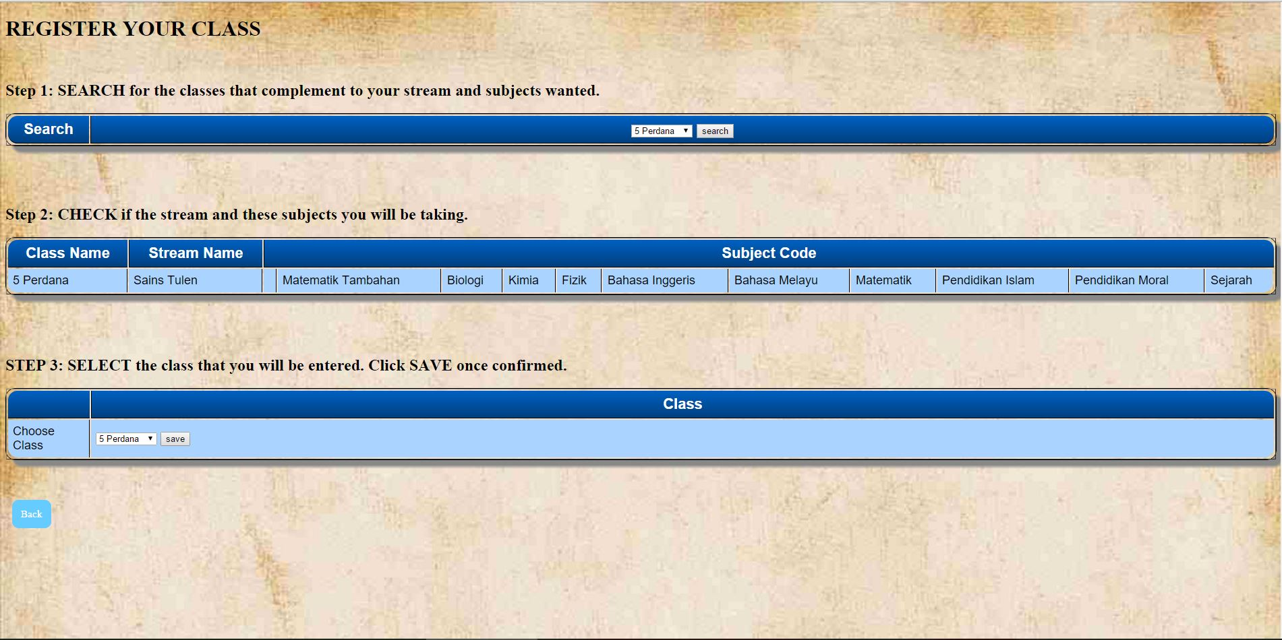

*Figure 13 shows the instructions of registering the student’s class for student.*

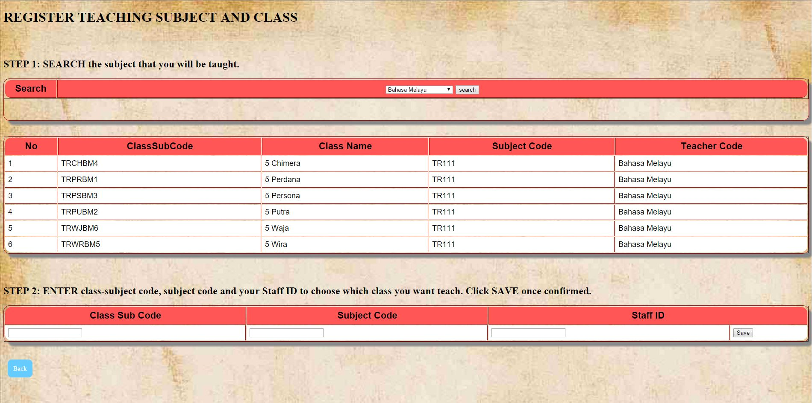

*Figure 14 shows the instructions of registering teaching subject and class for teacher.*